**Task # 1**

**Code:**

#include <iostream>

#include <cstdlib>

#include <unistd.h>

#include <sys/wait.h>

using namespace std;

int main() {

pid_t pid = fork();

if (pid < 0) {

cerr << "Fork failed" << endl;

return 1;

} else if (pid == 0) {

cout << "Child process:" << endl;

execlp("/bin/ls", "ls", (char *)NULL);

exit(0);

} else {

wait(NULL);

cout << endl << "Parent process: Child process has terminated" << endl;

}

return 0;

}

**Implementation:**

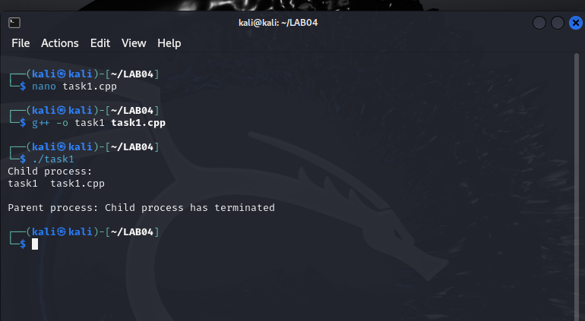

**Task # 2**

**Code:**

#include <stdio.h>

#include <unistd.h>

#include <sys/types.h>

int main() {

pid_t pid = getpid();

printf("Process ID: %d\n", pid);

pid_t child_pid = fork();

if (child_pid < 0) {

fprintf(stderr, "Fork failed\n");

return 1;

} else if (child_pid == 0) {

printf("Child process: PID = %d, Parent PID = %d\n", getpid(), getppid());

} else {

printf("Parent process: PID = %d, Child PID = %d\n", getpid(), child_pid);

}

return 0;

}

**Implementation:**

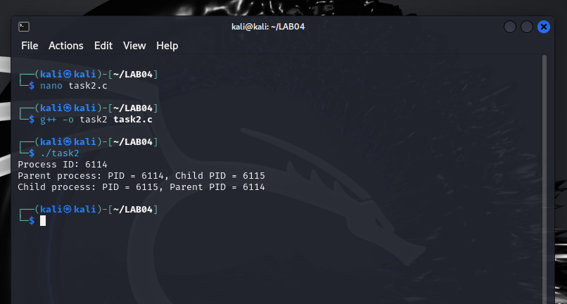

**Task # 3**

**Code:**

#include <stdio.h>

#include <stdlib.h>

#include <fcntl.h>

#include <unistd.h>

#define BUFFER_SIZE 4096

int main(int argc, char *argv[]) {

if (argc != 3) {

fprintf(stderr, "Usage: %s <source_file> <destination_file>\n", argv[0]);

return 1;

}

int source_fd = open(argv[1], O_RDONLY);

if (source_fd == -1) {

perror("Failed to open source file");

return 1;

}

int dest_fd = open(argv[2], O_WRONLY | O_CREAT | O_TRUNC, 0666);

if (dest_fd == -1) {

perror("Failed to open destination file");

close(source_fd);

return 1;

}

char buffer[BUFFER_SIZE];

ssize_t bytes_read, bytes_written;

while ((bytes_read = read(source_fd, buffer, BUFFER_SIZE)) > 0) {

bytes_written = write(dest_fd, buffer, bytes_read);

if (bytes_written != bytes_read) {

perror("Write error");

close(source_fd);

close(dest_fd);

return 1;

}

}

if (bytes_read == -1) {

perror("Read error");

close(source_fd);

close(dest_fd);

return 1;

}

if (close(source_fd) == -1) {

perror("Failed to close source file");

return 1;

}

if (close(dest_fd) == -1) {

perror("Failed to close destination file");

return 1;

}

printf("File copied successfully.\n");

return 0;

}

**Implementation:**

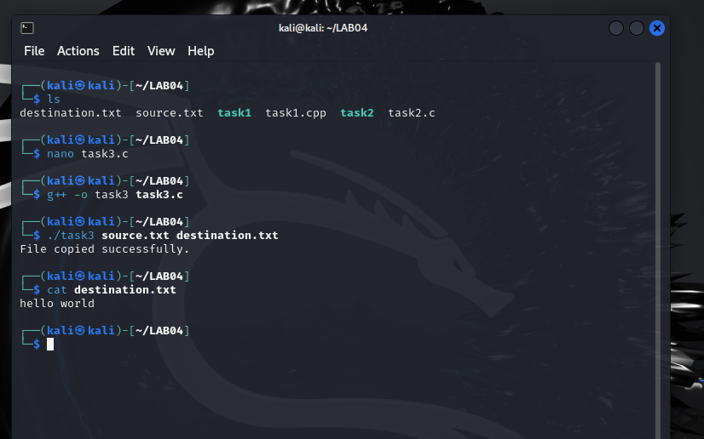

**Task # 4**

**Code:**

#include <stdio.h>

#include <stdlib.h>

#include <dirent.h>

#include <sys/stat.h>

#include <string.h>

void listFiles(const char *path) {

DIR *dir;

struct dirent *entry;

struct stat statbuf;

dir = opendir(path);

if (dir == NULL) {

perror("opendir");

return;

}

while ((entry = readdir(dir)) != NULL) {

char filepath[1024];

snprintf(filepath, sizeof(filepath), "%s/%s", path, entry->d_name);

if (lstat(filepath, &statbuf) == -1) {

perror("lstat");

continue;

}

if (S_ISDIR(statbuf.st_mode)) {

if (strcmp(entry->d_name, ".") == 0 || strcmp(entry->d_name, "..") == 0)

continue;

printf("Directory: %s\n", entry->d_name);

listFiles(filepath);

} else if (S_ISREG(statbuf.st_mode)) {

printf("File: %s\n", entry->d_name);

}

}

closedir(dir);

}

int main() {

listFiles(".");

return 0;

}

**Implementation:**

